4.17
Stage 2 testing report.
Success.
We're accept the firmware version 1.1.0005 to the first two x600 and x1100 containers.
The next step is stage 3: selecting a random device from a container and testing it separately.
But there's one big problem...
The big problem is the need to fix the firmware. Future firmware version will require sending Passage Information via the subnet broadcast IP address (255), rather than directly.
Future V-series containers should also have this updated firmware
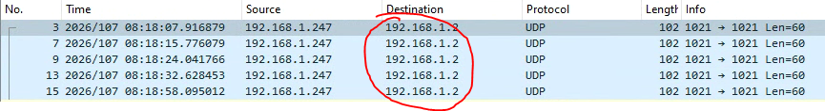
4.21
V900 1.1.5 test FAIL:
The Set Wirking Mode test failed.
A false positive error was returned from the device - valid operational settings were rejected as invalid.
- Fix this please! Make these descriptions valid and equal.
V900 из 4х попыток 2 раза не ползволил установить правильные настройки режима работы. Даёт осечки, примерно 50 на 50.

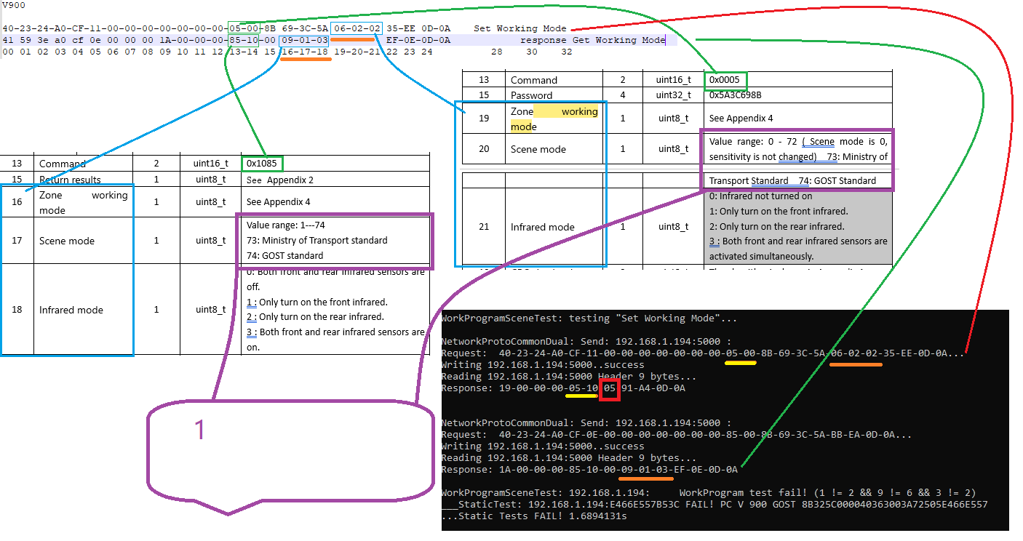

23.04
Could you rerecode the firmware up to 1.1.6
Agreed that firmware 1.1.6 will broadcast UDP pass messages to the subnet
and that’s how they work now V900 V1800 (в офисе старые)

24.04
@贺顺军
The First Stage of V900 testing has been successfully completed.
I reminder, 12 units of V900 devices have completed the second phase...

MV6 Firt Stage report:
Settings OK.
Alarms FAIL.
The device does not send passage messages (255.255.255.255) correctly and does not send alarm messages in response to the alarm simulation command. 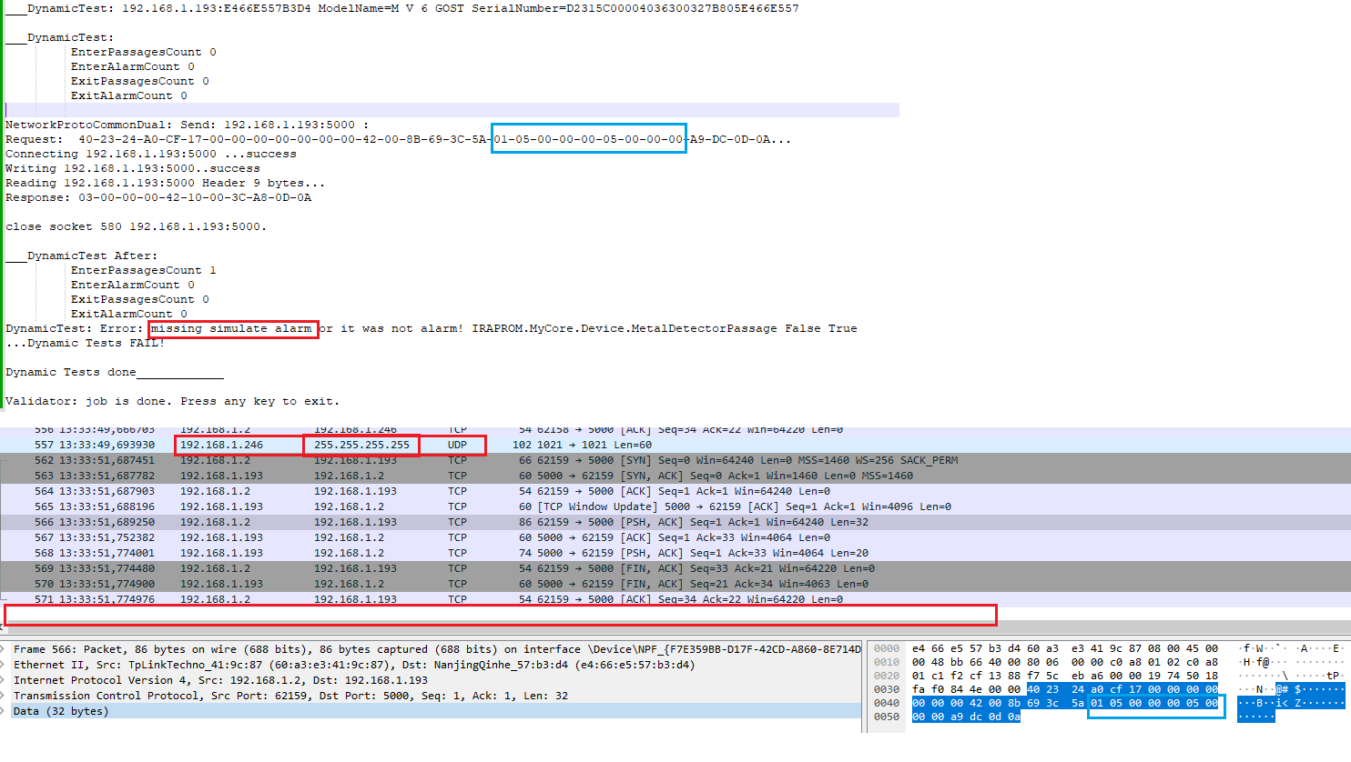

27.04
@斌
OK.
You can prepare 12 or 24 untis of MV6 for Second Stage of tests. Have you prepared 24 units or at least 12 of v900 for tests?

28.04
@贺顺军
V900 Stage 2 tests OK.
Connect please MV6 units.

29.04
MV6 error
Did nit execute Simulate Alarm command
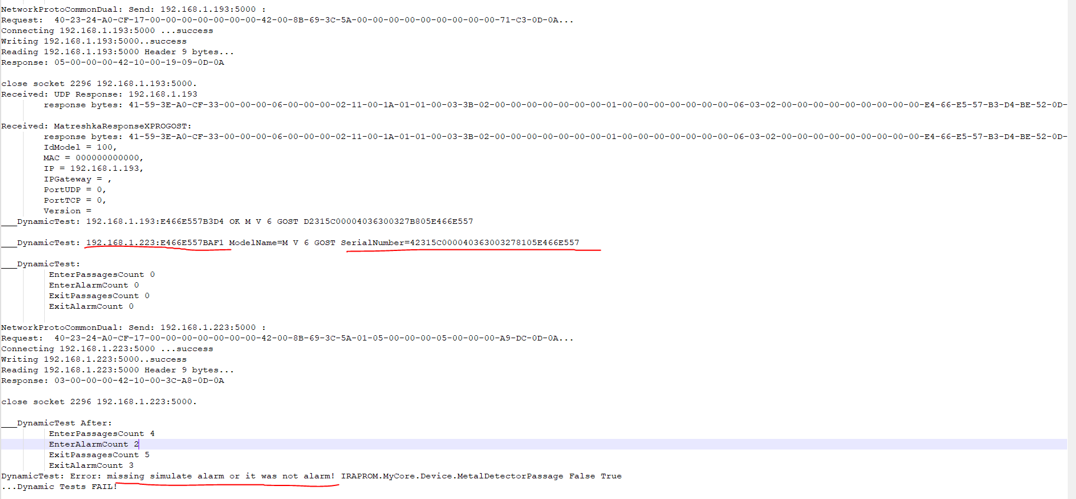

30.04
MV6 50/50 responds Simulate Alarm command

06.05.
MV6 stage 2 SUCCESS
The firmware version is 1.1.8

